YUVA INTERN TASK 5

HR ANALYTICS &
INSIGHTS DOCUMENTATION
Employee Attrition Analysis Using Python
Prepared by: Jaykant Kumar
Programme : Bachelor of Computer Applications (BCA)
Institution: International School of Management, Patna
Domain: Data Analyst
Tools: Python, Pandas, NumPy, Matplotlib, Jupyter Notebook
Dataset file analysed: HR_Analytics.csv
Report date: 03 November 2026
This report continues the same HR Analytics project completed in Task 4.
Findings describe the supplied dataset and do not prove causation.

ANALYTICAL REPORT | PYTHON • PANDAS • DATA VISUALIZATION • BUSINESS INSIGHTS

Report Navigation and Executive Dashboard
This report is organized as a detailed professional document equivalent in coverage to a 30–40-slide presentation, but formatted as a Word report because the task portal specifically requests a .doc or .docx file. The content is deliberately grouped into compact sections, tables and figures rather than leaving one mostly empty page for every topic.
Part | Coverage
A. Project foundation | Summary, context, business problem, objectives, scope and questions
B. Data and method | Dataset, data dictionary, tools, methodology, quality checks and metric definitions
C. Results | Overall attrition and six group-level comparisons with tables and charts
D. Insights and actions | Cross-group findings, recommendations, implementation plan and KPIs
E. Responsible reporting | Ethics, limitations, validation, learning outcomes and conclusion
F. Appendices | Python code, chart code, GitHub structure, 200+ word submission description and references

Key measure | Result | Interpretation
Employee records | 1,480 | Rows analyzed
Columns | 38 | Dataset attributes
Attrition = Yes | 238 | Recorded attrition cases
Attrition = No | 1,242 | Records marked No
Overall attrition | 16.08% | 238 ÷ 1,480 × 100
Missing cells | 57 | In YearsWithCurrManager
Exact duplicate rows | 7 | Detected in initial quality check

1. Executive Summary
The project examines employee attrition in the supplied HR_Analytics.csv dataset and converts raw employee records into understandable metrics, comparisons and practical HR insights. The dataset contains 1,480 records and 38 columns. A total of 238 records are labelled Attrition = Yes and 1,242 are labelled No, giving an overall recorded attrition rate of 16.08%. Python, Pandas, NumPy, Matplotlib, Seaborn and Jupyter Notebook are used to inspect, summarize and visualize the information.

Interpretation and practical meaning
The overtime group records 30.62%, compared with 10.36% for the non-overtime group. Sales has a 20.67% department rate. Sales Representative has the highest listed job-role rate at 39.29%. The 18–25 age group records 35.77%, the Up to 5k salary slab records 21.65%, and the Single category records 25.37%. These are descriptive comparisons, not causal explanations.

2. Introduction to HR Analytics
HR analytics is the structured use of workforce information to understand patterns and support better organizational decisions. It can help HR teams review recruitment, employee experience, workforce planning, retention, training and staffing. This project uses descriptive analytics to examine the Attrition field and compare it across selected employee categories.

Interpretation and practical meaning
A CSV file contains rows and columns but does not automatically explain what is important. Analysis organizes records, checks quality, calculates comparable measures and presents results in charts. Interpretation then translates the numbers into questions that HR can investigate.

3. Business Background
Employee departures may affect continuity, service quality, team knowledge, recruitment workload and training costs. When departures are concentrated in a role or work setting, the organization may need to review workload, management support, job expectations or development opportunities. These possibilities must be investigated rather than assumed.

Interpretation and practical meaning
Analytics can help identify where further questions are useful. A rate is a signal for inquiry, not a performance score for an employee or manager.

4. Problem Statement
The central business problem is the need to understand how recorded employee attrition varies across the available workforce categories and how those patterns can be communicated responsibly.

Interpretation and practical meaning
Key questions include: What is the overall recorded rate? Which departments and roles show higher rates? How does attrition differ by overtime, age, salary and marital status? What data-quality issues could affect interpretation? What fair actions can HR investigate?

5. Project Aim and Objectives
The aim is to demonstrate an end-to-end descriptive analytics and reporting workflow using Python-based tools and the supplied HR dataset.

Interpretation and practical meaning
Objectives:
load and inspect the CSV; understand important fields; review missing values, duplicates and category labels; calculate overall and group-level rates; create charts and tables; interpret findings cautiously; recommend fair actions; and document methods, limitations and learning outcomes.

6. Scope and Boundaries
The project covers descriptive analysis of the supplied dataset. It does not determine the true reason for each departure, prove causation, build a validated prediction model or make decisions about individual employees.

Interpretation and practical meaning
Included: CSV loading, inspection, quality checks, grouping, percentage calculations, visualization, interpretation and reporting. Excluded: individual risk scoring, automated employment decisions and generalization to all organizations.

6.1 Importance of Project Scope
Defining the scope of this project helps maintain a clear direction throughout the analysis. It ensures that the work remains focused on the supplied HR dataset and the questions related to employee attrition.
The project focuses on understanding workforce patterns through descriptive analytics. It uses employee-related information to calculate percentages, compare categories and identify areas that may require further investigation by HR professionals.
6.2 Expected Project Outcomes
The expected outcomes of this project include:
- A clear understanding of the structure and quality of the HR dataset.
- Identification of missing values and duplicate records.
- Calculation of the overall employee attrition rate.
- Comparison of attrition across departments and job roles.
- Understanding of the relationship between overtime status and recorded attrition.
- Identification of differences across age groups, salary slabs and marital-status categories.
- Creation of charts and tables for better interpretation.
- Development of practical and fair HR recommendations.
6.3 Limitations of the Project
This project is based on the available dataset and its recorded information. Some limitations should be considered while interpreting the results.
The analysis does not establish the actual reasons behind employee departures. It identifies patterns and differences but cannot prove that a particular factor directly causes attrition. The findings also depend on the accuracy, completeness and consistency of the supplied data.
Therefore, the results should be treated as descriptive insights rather than final conclusions about individual employees or the entire organization.

7. Dataset Overview
The supplied HR_Analytics.csv file contains 1,480 rows and 38 columns. Each row is treated as an employee record for this exercise. Fields include employee characteristics, department, job role, compensation, work experience, satisfaction-related measures and an Attrition outcome.

Interpretation and practical meaning
The file contains 238 Yes labels and 1,242 No labels. Initial quality review reported 57 missing cells in YearsWithCurrManager and 7 exact duplicate rows.

8. Data Dictionary
A data dictionary explains what each field represents and how it is used. Understanding field meaning before calculating rates prevents incorrect comparisons.

Interpretation and practical meaning
Attrition: Yes/No outcome label. Department: business unit. JobRole: role category. OverTime: recorded overtime status. AgeGroup: grouped age category. SalarySlab: grouped monthly salary band. MaritalStatus: recorded marital-status category. YearsWithCurrManager: tenure-related field with missing values.

9. Tools and Technologies
The project uses a Python analytics workflow. Each tool supports a distinct task in the analysis and reporting process.

Interpretation and practical meaning
Python executes the workflow; Pandas reads and summarizes tables; NumPy supports numerical operations; Matplotlib and Seaborn create visualizations; Jupyter Notebook keeps code and outputs together; Microsoft Word presents the final report.

10. End-to-End Methodology
The workflow follows a repeatable sequence designed to make the analysis understandable and auditable.

Interpretation and practical meaning
Define the question; load and preserve the source; inspect dimensions and data types; assess quality; prepare confirmed category variations; calculate rates; create charts; interpret results; document limitations; and validate that report figures match notebook outputs.

11. Data Loading and Initial Inspection
Data loading is the first technical step. Confirm that the correct file has been read and that expected fields are available. A wrong path or similarly named file can lead to incorrect results.

Interpretation and practical meaning
Use pd.read_csv() to load the file, df.shape for dimensions, df.head() for preview, df.info() for data types and non-null counts, df.columns for field names, and df.describe(include='all') for a broad summary.

12. Data Quality Assessment
The initial review identified 57 missing cells in YearsWithCurrManager, 7 exact duplicate rows, and a category-label variation in BusinessTravel where TravelRarely and Travel_Rarely both appear.

Interpretation and practical meaning
Missing values must not automatically be replaced with zero. Duplicate rows should be checked against employee identifiers and source context before removal. Category labels should be standardized only after confirming that the labels mean the same thing.

13. Data Cleaning and Preparation
Cleaning improves consistency while preserving original information. Create a working copy, apply documented transformations and compare the result with the original.

Interpretation and practical meaning
Keep an untouched source copy; inspect missing values; verify duplicates; trim accidental spaces; standardize confirmed label variations; avoid arbitrary imputation; record every transformation and recheck row counts and categories.

14. Defining the Attrition Metric
Consistent metric definitions are essential. The overall rate uses all eligible records as its denominator. A subgroup rate uses only records belonging to that group.

Interpretation and practical meaning
Formula: Attrition rate (%) = (records marked Yes ÷ total records in the group) × 100. Example: 30 Yes records out of 100 group records equals 30%. Always show the Yes count, total group count and percentage.

15. Exploratory Data Analysis
Exploratory Data Analysis helps understand the dataset before interpretation. It examines distributions, categories, unusual values, missing information and differences between groups.

Interpretation and practical meaning
Univariate analysis studies one field at a time. Grouped analysis compares attrition by category. Charts reveal patterns but should be checked against counts. Small groups can produce unstable percentages.

15.1 Key Analytical Approaches
The analysis uses three important approaches:
- Descriptive Analysis: Summarizes employee records using counts, percentages and averages.
- Comparative Analysis: Compares attrition rates across departments, job roles and employee categories.
- Visual Analysis: Uses charts and graphs to present patterns in a simple and understandable format.
15.2 Analytical Importance
These approaches help convert raw employee data into meaningful information. They make it easier to identify workforce patterns, understand differences between groups and highlight areas where further HR investigation may be useful.
The analysis focuses on accuracy, transparency and responsible interpretation rather than making assumptions about individual employees.

16. Overall Attrition Analysis
The dataset contains 238 records marked Yes and 1,242 records marked No, out of 1,480 total records. The calculation is 238 ÷ 1,480 × 100 = 16.08%.

Interpretation and practical meaning
Approximately 16 out of every 100 records are marked Yes in this dataset. This should not be called a current annual company-wide rate unless the data source and measurement period confirm that interpretation.
Outcome | Records | Share
Attrition = Yes | 238 | 16.08%
Attrition = No | 1,242 | 83.92%
Total | 1,480 | 100.00%

17. Department-Level Analysis
Department-level comparison shows how the recorded rate differs across Sales, Human Resources and Research & Development.

Interpretation and practical meaning
Sales has the highest rate at 20.67%, followed by Human Resources at 19.05%. Research & Development records 13.75%. Human Resources has a smaller group, so its percentage should be interpreted alongside its denominator. Review workload, staffing, role mix, manager support and career progression.
Department | Attrition Yes | Total records | Rate
Sales | 93 | 450 | 20.67%
Human Resources | 12 | 63 | 19.05%
Research & Development | 133 | 967 | 13.75%

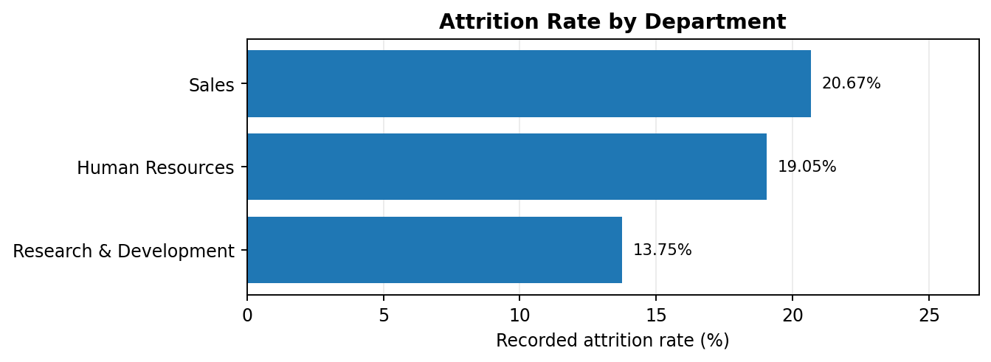
Figure: Recorded attrition rate by department. Percentages are descriptive and should be read with the group counts.

18. Job-Role Analysis
Job roles can differ in customer contact, targets, schedules, technical requirements, training needs and career paths. Role-level comparisons can identify where deeper review may be useful.

Interpretation and practical meaning
Sales Representative records the highest listed rate at 39.29% (33 of 84). Laboratory Technician is 23.75% (62 of 261), and Human Resources is 23.08% (12 of 52). Research Director records 2.50% (2 of 80). Review onboarding, expectations, training, workload, pay bands and progression.
Job Role | Attrition Yes | Total records | Rate
Sales Representative | 33 | 84 | 39.29%
Laboratory Technician | 62 | 261 | 23.75%
Human Resources | 12 | 52 | 23.08%
Sales Executive | 58 | 329 | 17.63%
Research Scientist | 47 | 293 | 16.04%
Healthcare Representative | 9 | 132 | 6.82%
Manufacturing Director | 10 | 147 | 6.80%
Manager | 5 | 102 | 4.90%
Research Director | 2 | 80 | 2.50%

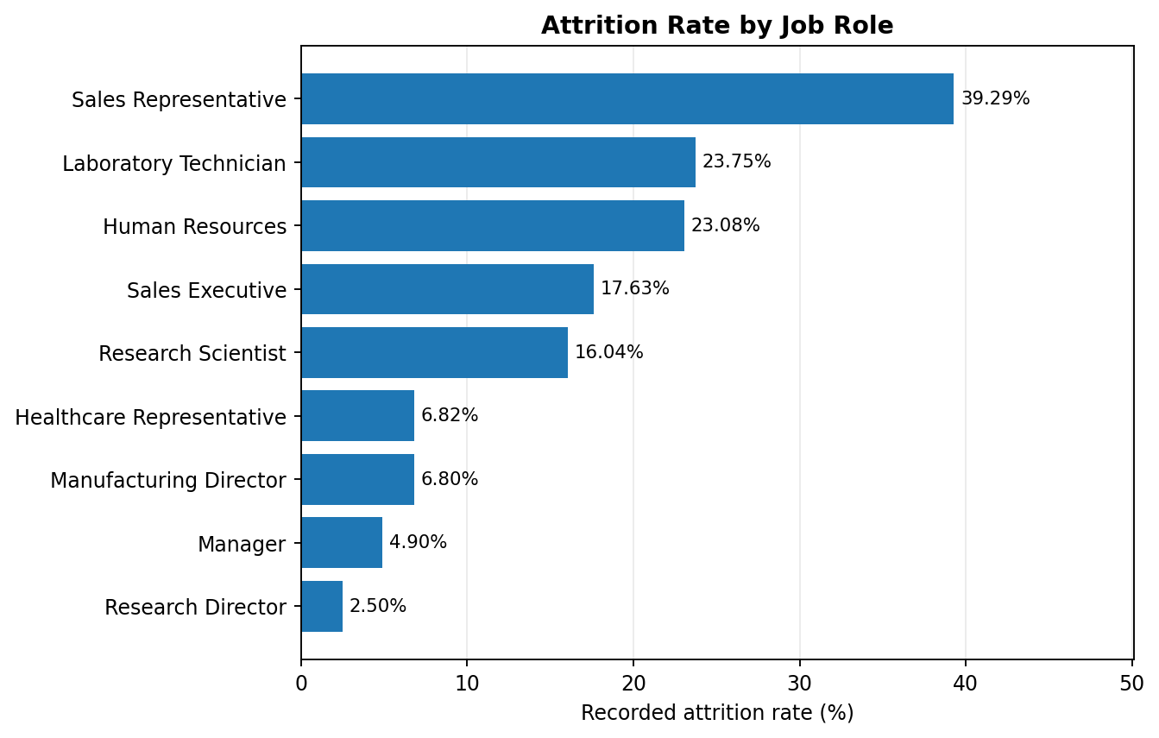
Figure: Recorded attrition rate by job role. Percentages are descriptive and should be read with the group counts.

19. Overtime Analysis
The OverTime = Yes group records 128 Yes cases among 418 records, giving 30.62%. The OverTime = No group records 110 Yes cases among 1,062 records, giving 10.36%.

Interpretation and practical meaning
The overtime group's observed rate is about three times the non-overtime rate. This is a notable association, not proof that overtime alone causes attrition. Review overtime frequency, hours, staffing, schedule predictability, rest periods and employee feedback.
Overtime | Attrition Yes | Total records | Rate
Yes | 128 | 418 | 30.62%
No | 110 | 1062 | 10.36%

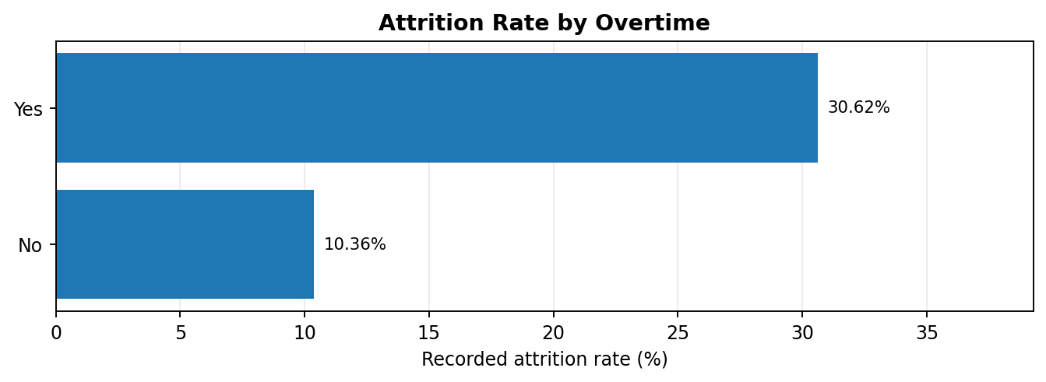
Figure: Recorded attrition rate by overtime. Percentages are descriptive and should be read with the group counts.

20. Age-Group Analysis
The 18–25 category records 44 Yes cases among 123 records, or 35.77%. The 26–35 group records 18.99%, the 36–45 group 9.13%, the 46–55 group 11.84%, and the 55+ group 17.02%.

Interpretation and practical meaning
The youngest age band has the highest observed rate. The 55+ group contains only 47 records, so its percentage is more sensitive to small count changes. Investigate onboarding, mentoring, training access and career clarity; do not stereotype by age.
Age Group | Attrition Yes | Total records | Rate
18–25 | 44 | 123 | 35.77%
26–35 | 116 | 611 | 18.99%
36–45 | 43 | 471 | 9.13%
46–55 | 27 | 228 | 11.84%
55+ | 8 | 47 | 17.02%

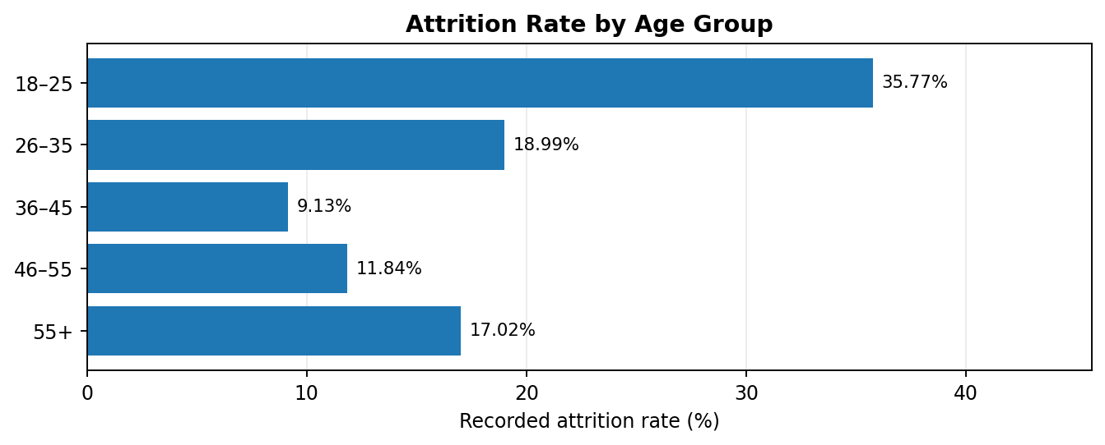
Figure: Recorded attrition rate by age group. Percentages are descriptive and should be read with the group counts.

21. Salary-Slab Analysis
The Up to 5k category records 163 Yes cases among 753 records, or 21.65%. The 15k+ category records 5 Yes cases among 133 records, or 3.76%.

Interpretation and practical meaning
The lowest salary slab has the highest observed rate. Salary alone cannot explain departures; role level, experience, location, working conditions and career opportunities may differ. Review compensation consistently against responsibilities and appropriate benchmarks.
Salary Slab | Attrition Yes | Total records | Rate
Up to 5k | 163 | 753 | 21.65%
5k–10k | 49 | 444 | 11.04%
10k–15k | 21 | 150 | 14.00%
15k+ | 5 | 133 | 3.76%

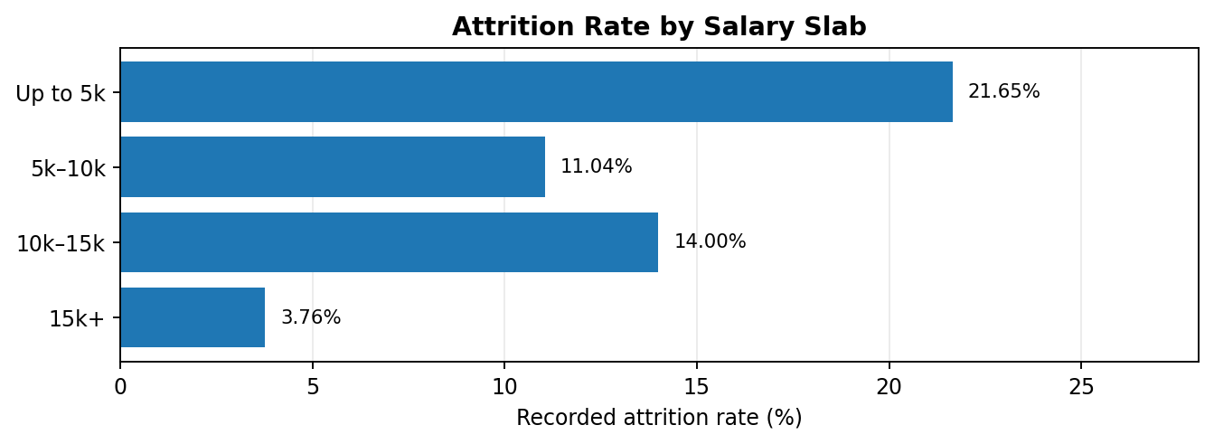
Figure: Recorded attrition rate by salary slab. Percentages are descriptive and should be read with the group counts.

22. Marital-Status Analysis
The dataset records 120 Yes cases among 473 Single records, 84 among 679 Married records, and 34 among 328 Divorced records.

Interpretation and practical meaning
Single records the highest observed rate at 25.37%, followed by Married at 12.37% and Divorced at 10.37%. This is descriptive only. Marital status is personal information and must not be used to stereotype or disadvantage employees.
Marital Status | Attrition Yes | Total records | Rate
Single | 120 | 473 | 25.37%
Married | 84 | 679 | 12.37%
Divorced | 34 | 328 | 10.37%

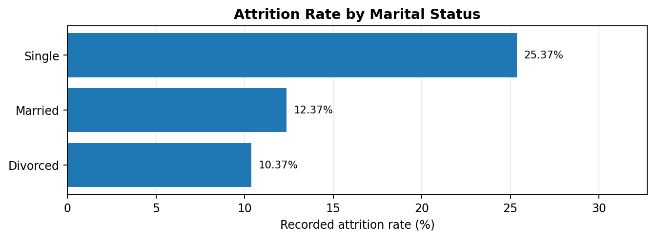
Figure: Recorded attrition rate by marital status. Percentages are descriptive and should be read with the group counts.
22.1 Key Findings and Business Insights
The analysis shows noticeable differences in recorded attrition across marital-status groups. Single employees have the highest recorded attrition rate at 25.37%, while married employees have a rate of 12.37%. Divorced employees show a rate of 10.37%.
These differences provide useful information for understanding workforce patterns. However, marital status alone cannot explain why employees leave an organization. Other factors, such as job satisfaction, work environment, career opportunities, compensation and workload, may also influence employee decisions.
22.2 HR Recommendations
HR teams should focus on understanding employee needs through confidential feedback, engagement surveys and regular discussions. They should provide equal career development opportunities and maintain a supportive workplace for all employees.
Marital status should be treated only as a descriptive category in this analysis. It must never be used to discriminate against employees or make individual hiring, promotion or retention decisions.

23. Cross-Group Comparison
The highest observed categories across dimensions help prioritize questions, but they should not be treated as one combined ranking because each uses a different denominator.

Interpretation and practical meaning
Department: Sales 20.67%; job role: Sales Representative 39.29%; overtime: Yes 30.62%; age: 18–25 35.77%; salary: Up to 5k 21.65%; marital status: Single 25.37%. Counts and sample sizes must remain visible.

24. Key Analytical Findings
The main findings are that overall recorded attrition is 16.08%, rates differ by department and job role, and the overtime group has a substantially higher observed rate than the non-overtime group.

Interpretation and practical meaning
The youngest age band, lowest salary slab and Single category also show higher observed rates in their respective comparisons. These findings guide further investigation; they do not reveal individual reasons for leaving or prove causes.

25. Business Insights
Business insights translate numerical findings into practical questions. The goal is to examine work systems and employee experience rather than blame a group.

Interpretation and practical meaning
Review workload and overtime; examine onboarding and role support; improve early-career mentoring; check compensation fairness; and use confidential employee feedback to add context unavailable in the CSV.

25.1 Recommended Action Plan
Based on the analytical findings, the organization can consider the following actions:
- Workload Management: Review overtime patterns and ensure that employees receive reasonable workloads and sufficient rest.
- Employee Engagement: Conduct regular feedback sessions to understand employee concerns and workplace expectations.
- Career Development: Provide training, mentoring and growth opportunities, especially for employees in early career stages.
- Compensation Review: Examine salary structures to ensure fairness and consistency across comparable roles.
- Retention Monitoring: Track attrition rates regularly and compare results across departments and job roles.
25.2 Expected Benefits
These actions may help HR teams identify workplace challenges, improve employee experience and develop better retention strategies. Their effectiveness should be evaluated through regular employee feedback and measurable workforce indicators.

26. Actionable HR Recommendations
Recommendations should be practical, fair, measurable and connected to the observed evidence. Begin with investigation or improvement pilots rather than assumptions about individuals.

Interpretation and practical meaning
Review overtime hours and staffing; strengthen role-specific onboarding; offer mentoring and career-path clarity; review compensation bands; collect confidential feedback; improve data quality; and monitor aggregated trends over time.

27. Implementation Roadmap
A phased plan turns findings into manageable actions. These are proposed planning windows, not claims that the work has already been completed.

Interpretation and practical meaning
Weeks 1–2: validate data definitions and quality. Weeks 3–4: review overtime and role context. Month 2: pilot workload, onboarding or training improvements. Monthly or quarterly: monitor consistent indicators. After the pilot: evaluate outcomes and unintended effects.

28. KPI Monitoring Framework
Monitoring requires stable definitions and comparable time periods. A dashboard should support learning and improvement rather than encourage managers to hide departures.

Interpretation and practical meaning
Suggested KPIs: overall attrition rate; department attrition; overtime exposure; early-tenure attrition; training completion; and aggregated employee feedback themes. Define the numerator, denominator and period for each KPI.

29. Visualization and Reporting Standards
Charts should clarify results without exaggerating differences. Horizontal bar charts are suitable for comparing category rates and keeping longer labels readable.

Interpretation and practical meaning
Use clear titles and axes, consistent percentage precision, nearby counts and denominators, consistent scales, readable labels and no misleading 3D effects. Explain small samples and ensure figures match notebook outputs.
28.1 KPI Evaluation and Performance Review
Key Performance Indicators help HR teams evaluate workforce trends over time. Regular monitoring makes it possible to identify changes in attrition, overtime exposure and employee engagement.
HR teams should compare monthly and quarterly results using consistent definitions. Any major change should be investigated through employee feedback and additional workforce information rather than relying only on percentages.
29.1 Importance of Effective Data Visualization
Data visualization makes complex analytical results easier to understand. Well-designed charts help managers compare employee groups, identify patterns and communicate findings clearly.
Every visualization should include an appropriate title, readable labels, percentage values and relevant group counts. Accurate presentation improves transparency and reduces the possibility of misleading interpretations.
29.2 Reporting Quality
A professional analytical report should connect every chart with a clear explanation. The written interpretation should describe what the data shows, why the finding may be useful and what further investigation could be required.

30. Data Ethics, Privacy and Fairness
Employee records contain personal and employment information. They should be used only for legitimate purposes, with appropriate access controls and data minimization.

Interpretation and practical meaning
Restrict raw-data access; prefer aggregated reporting; do not use age or marital status to disadvantage employees; avoid automated employment decisions; suppress small groups when needed; protect employee feedback; and maintain human oversight.

31. Limitations and Risks
The findings must be interpreted within the boundaries of the supplied file and descriptive methods.

Interpretation and practical meaning
The source, sampling method and measurement period are not established here. The data may not represent a current workforce. Association is not causation. Group sizes differ. Role, pay, tenure and overtime may overlap. Missing values and duplicates require review.

32. Testing and Validation
Validation checks whether the report can be reproduced and whether its figures agree with the notebook.

Interpretation and practical meaning
Confirm the filename and path; restart and run all notebook cells; verify 1,480 × 38 dimensions; confirm 238 Yes and 1,242 No; recalculate 16.08%; verify subgroup denominators; review quality checks; and compare every chart with final outputs.

32.1 Quality Assurance Checklist
The following checks help maintain the accuracy and reliability of the final report:
- Dataset Verification: Confirm that the correct HR Analytics CSV file is used.
- Record Verification: Check that the dataset contains 1,480 rows and 38 columns.
- Attrition Verification: Confirm 238 Yes records and 1,242 No records.
- Percentage Verification: Recalculate the overall attrition rate and subgroup percentages.
- Chart Verification: Ensure that every chart represents the correct values and category labels.
- Report Consistency: Compare tables, charts and written explanations to avoid conflicting information.
32.2 Importance of Validation
Validation is an important part of every data analytics project. It helps identify calculation errors, incorrect labels and inconsistencies between the dataset and final report.
A properly validated report is easier to understand, reproduce and review. All findings should be supported by the available dataset, and any unresolved data-quality issue should be clearly documented.

33. Learning Outcomes
The project demonstrates practical data analytics and the ability to communicate results in business language.

Interpretation and practical meaning
Skills practiced include CSV loading, DataFrame inspection, missing-value and duplicate checks, category preparation, grouping, percentage calculations, chart creation, interpretation, recommendation writing, privacy awareness and professional reporting.

34. Conclusion and Future Scope
The project analyzed 1,480 records and 38 columns. The overall recorded attrition rate is 16.08%. Rates differ across departments, job roles, overtime, age groups, salary slabs and marital-status categories.

Interpretation and practical meaning
The report demonstrates how Python tools turn raw records into structured findings. Future work could include confirmed time-based trends, tenure analysis, employee survey themes and carefully validated statistical methods. Any predictive model would require independent validation, fairness checks and governance.

35. Final Submission Checklist
Before uploading Task 5, confirm that the report and supporting project files are complete and consistent with the work performed.

Interpretation and practical meaning
Upload this .docx report; retain the executed Jupyter Notebook; ensure charts match the notebook; enter a GitHub URL only after creating and checking the repository; do not publish raw HR data without permission; and paste the 200+ word description from the appendix into the form.

35.1 Project Completion Summary
The HR Analytics project covers the major stages of a practical data analytics workflow, beginning with dataset inspection and ending with business recommendations. It demonstrates how raw employee information can be processed, analyzed and presented in a structured format.
The project also highlights the importance of checking data quality, verifying calculations and presenting findings with appropriate explanations. Each stage contributes to making the final report more reliable and understandable.
35.2 Overall Project Impact
This project has improved practical knowledge of Python-based data analysis and professional reporting. It demonstrates the use of Pandas and NumPy for data processing and Matplotlib and Seaborn for visualization.
The experience gained through this project can support future work in HR Analytics, business intelligence and data-driven decision-making. It also provides a foundation for more advanced projects involving larger datasets and additional analytical techniques.
35.3 Final Note
All conclusions in this report are based on the supplied dataset and the analysis performed. The findings should be interpreted responsibly, with attention to data limitations, employee privacy and fairness.

Appendix A – KPI Definition Examples
KPI | Suggested definition | Purpose
Overall attrition | Eligible departures ÷ defined eligible workforce × 100 | Track overall retention over a fixed period
Department attrition | Department departures ÷ department workforce | Identify areas for contextual review
Overtime exposure | Employees with overtime and/or total overtime hours by team | Monitor workload signals
Early-tenure attrition | Departures within a defined first-year period ÷ eligible hires | Assess onboarding experience
Training completion | Employees completing required training ÷ assigned employees | Review role preparation
Feedback themes | Aggregated confidential survey/interview themes | Add context beyond the dataset

Appendix B – Reproducible Python Code
Run this example in Jupyter Notebook in the same folder as the CSV file. If your file has a different exact filename, update the read_csv path.
import pandas as pd
import numpy as np
import matplotlib.pyplot as plt
import seaborn as sns
df = pd.read_csv("HR_Analytics.csv")
print("Dataset shape:", df.shape)
display(df.head())
df.info()
print(df.isna().sum().sort_values(ascending=False).head(10))
print("Exact duplicate rows:", df.duplicated().sum())
df["Attrition_clean"] = df["Attrition"].astype(str).str.strip().str.lower()
yes_count = df["Attrition_clean"].eq("yes").sum()
overall_rate = yes_count / len(df) * 100
print("Overall attrition rate:", round(overall_rate, 2), "%")
def attrition_summary(column):
result = df.groupby(column)["Attrition_clean"].agg(
total_records="count",
attrition_yes=lambda s: s.eq("yes").sum()
)
result["rate_pct"] = (
result["attrition_yes"] / result["total_records"] * 100
).round(2)
return result.sort_values("rate_pct", ascending=False)
for col in ["Department", "JobRole", "OverTime",
"AgeGroup", "SalarySlab", "MaritalStatus"]:
print("\\n", col)
display(attrition_summary(col))

Appendix C – Example Visualization Code
summary = attrition_summary("Department")
ax = summary["rate_pct"].plot(
kind="bar", figsize=(8, 5),
title="Attrition Rate by Department"
)
ax.set_xlabel("Department")
ax.set_ylabel("Attrition rate (%)")
plt.xticks(rotation=20, ha="right")
plt.tight_layout()
plt.show()

Appendix D – Suggested GitHub Repository Structure
A repository improves reproducibility and makes the project easier to review. Only publish files that you are permitted to share. Do not upload private employee-level data or the raw HR dataset unless the data owner explicitly permits public sharing.
- hr-analytics-attrition-analysis/
- HR_Analytics_Attrition_Analysis.ipynb
- Task_5_Professional_HR_Analytics_Report.docx
- README.md
- charts/ (exported charts only)
The README should explain the objective, tools, setup instructions, analysis steps, key findings, limitations and data permissions. Enter a GitHub URL in the portal only after the repository has actually been created and checked.

References and Documentation
- Pandas documentation – https://pandas.pydata.org/docs/
- NumPy documentation – https://numpy.org/doc/
- Matplotlib documentation – https://matplotlib.org/stable/
- Seaborn documentation – https://seaborn.pydata.org/
- Jupyter documentation – https://docs.jupyter.org/
- Dataset: HR_Analytics.csv supplied for this project; confirm original source and sharing permissions separately.

Task 5 – Connection with Task 4
Task 4 was the practical analysis stage: loading the same HR dataset, checking and preparing data, calculating attrition rates and producing charts. Task 5 is the documentation and insight stage: explaining the business problem, describing the methods, presenting the same verified results, interpreting the findings, preparing recommendations and writing an executive-friendly report. Therefore, Task 5 continues the same project and does not require a different dataset or a new analysis topic. The figures in this report should remain aligned with the final Task 4 notebook.

